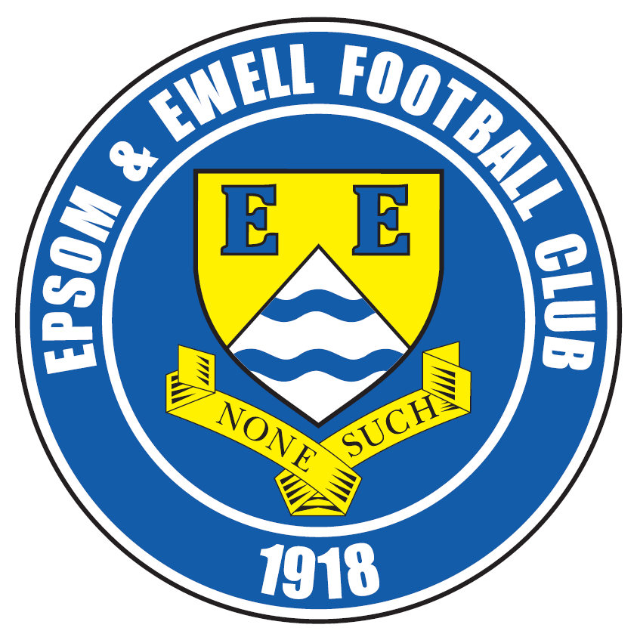 | Epsom & Ewell F.C.  2  v  Bridon Ropes  Sunday, 20th September 2020 – 3.00 p.m.
Good afternoon! Today we welcome the players, supporters and officials of Bridon Ropes to Fetcham Grove for this Buildbase F.A. Vase First Qualifying Round match and hope they have a safe journey home.

It would be understandable for Bridon to take a look around and think something was different, as the only time we met previously, the match was played at Chipstead; a Craig Hastings goal proving the difference between the two sides back in October 2016.

Of course much has changed now and we are no longer a Step Five team, although the winners of this match will host one in the next round in Langney Wanderers or Eastbourne United who were due to meet yesterday.

We were last here when Westside defeated us three nil in our opening match at Leatherhead. Since then we visited Bracknell Town for a League match with Sandhurst Town and outclassed them by six clear goals with new signing Charlie Penny scoring twice as did Bobby Bennett in a twenty minute cameo from the bench. Unfortunately we followed that up with a trip to Tooting Bec on Tuesday where we were edged out 2-1 with a goal in the final ten minutes after Jake Robinson had given us a lead.

It has been a frustrating start to the season. We have a positive goal difference and have only trailed for about twenty-five minutes out of 360, yet have three losses and find ourselves adrift of the top clubs already. We will hope to pick up points in our next two home matches over the next nine days and we are back here again on Saturday when Cove are the visitors, with the local derby against in form Chessington & Hook United coming up three days later. Why not come along?

Enjoy the match!

Rich

You can follow us on social media – just see the inside cover for details.


Cover photo by Gemma Jarman
Bobby Bennett scores our sixth goal against
Sandhurst Town on Saturday 12th September


Cherry Red Records Combined Counties League
Division One Table 2020/21
incl Tuesday 15th September | P | W | D | L | F | A | Pts | GD | H | A

Walton & Hersham | 4 | 3 | 1 | 0 | 19 | 0 | 10 | +19
Tooting Bec | 4 | 3 | 1 | 0 | 10 | 3 | 10 | +7 |  | 1-2
Chessington & Hook Utd | 4 | 3 | 0 | 1 | 9 | 4 | 9 | +5 | 29/9
Farnham Town | 4 | 3 | 0 | 1 | 8 | 4 | 9 | +4
Westside | 2 | 2 | 0 | 0 | 8 | 1 | 6 | +7 | 0-3
Jersey Bulls | 2 | 2 | 0 | 0 | 6 | 1 | 6 | +5
Ash United | 4 | 2 | 0 | 2 | 14 | 10 | 6 | +4
Kensington & Ealing Boro | 4 | 2 | 0 | 2 | 9 | 9 | 6 | 0
British Airways | 4 | 2 | 0 | 2 | 5 | 6 | 6 | -1
Bedfont & Feltham | 4 | 2 | 0 | 2 | 9 | 11 | 6 | -2
FC Deportivo Galicia | 3 | 1 | 1 | 1 | 9 | 5 | 4 | +4
Eversley & California | 3 | 1 | 1 | 1 | 5 | 4 | 4 | +1
Godalming Town | 3 | 1 | 1 | 1 | 5 | 4 | 4 | +1
Fleet Spurs | 4 | 1 | 1 | 2 | 4 | 5 | 4 | -1
Epsom & Ewell | 4 | 1 | 0 | 3 | 8 | 7 | 3 | +1 | x | x
Cove | 3 | 1 | 0 | 2 | 3 | 6 | 3 | -3 | 26/9
AFC Hayes | 3 | 1 | 0 | 2 | 5 | 10 | 3 | -5 |  | 1-2
Dorking Wanderers Res | 3 | 1 | 0 | 2 | 3 | 12 | 3 | -9
Sandhurst Town | 4 | 0 | 0 | 4 | 2 | 18 | 0 | -16 |  | 6-0
Bagshot | 4 | 0 | 0 | 4 | 0 | 21 | 0 | -21

Lucky Day? – 20th September
Played 16 - Won 6 Drawn 5 Lost 5 - For 29 Against 26 - PPG 1.44 - Average
Our Club record against Bridon Ropes
Played 1 - Won 1 Drawn 0 Lost 0 - For 1 Against 0 - PPG 3.00 - Perfect
Our Largest win against Bridon Ropes
22nd October 2016 - Won 1-0 – F.A.Vase First Round
Their Last Visit
22nd October 2016 - Won 1-0 – F.A.Vase First Round

First Eleven Appearances for 2020/21 - (max 4)
Name | Debut | 2020/21 |  |  |  | Career Totals
Name | Debut | App | Sub | Tot | Goals | App | Sub | Tot | Goals
ACHEAMPONG Gideon | 11/01/2020 | 4 | 0 | 4 | 0 | 13 | 0 | 13 | 1
AGYEMANG Dwayne | 05/09/2020 | 2 | 0 | 2 | 0 | 2 | 0 | 2 | 0
BAH Mamadou Alpha | 05/09/2020 | 0 | 3 | 3 | 0 | 0 | 3 | 3 | 0
BENNETT Bobby | 12/08/2018 | 2 | 2 | 4 | 2 | 68 | 5 | 73 | 40
CEESAY Shiekh | 23/02/2019 | 2 | 0 | 2 | 0 | 3 | 0 | 3 | 0
CONNELLY Lloyd | 14/10/2017 | 4 | 0 | 4 | 1 | 109 | 7 | 116 | 9
CURRIE-WILSON Ijah | 05/09/2020 | 3 | 1 | 4 | 0 | 3 | 1 | 4 | 0
HENDRY Rob | 08/08/2015 | 3 | 1 | 4 | 1 | 126 | 33 | 159 | 55
MARTIN Jordan | 12/09/2020 | 2 | 0 | 2 | 0 | 2 | 0 | 2 | 0
MARTIN Tony | 18/02/2020 | 4 | 0 | 4 | 1 | 4 | 1 | 5 | 1
MURPHY Scott | 20/01/2007 | 0 | 1 | 1 | 0 | 121 | 3 | 124 | 14
ORIMOLUSI Lekan | 08/09/2020 | 0 | 1 | 1 | 0 | 0 | 1 | 1 | 0
PENFOLD Daniel | 08/09/2020 | 1 | 1 | 2 | 0 | 1 | 1 | 2 | 0
PENNY Charlie | 12/09/2020 | 2 | 0 | 2 | 2 | 2 | 0 | 2 | 2
PENSON Tom** | 05/09/2020 | 1 | 0 | 1 | 0 | 1 | 0 | 1 | 0
ROBINSON Jake | 23/02/2019 | 4 | 0 | 4 | 1 | 33 | 5 | 38 | 4
SKELLY Jacob | 11/01/2020 | 0 | 2 | 2 | 0 | 8 | 3 | 11 | 1
SMITH Taryn | 28/10/2017 | 4 | 0 | 4 | 0 | 40 | 15 | 55 | 9
STRAKER Tariq | 16/11/2019 | 4 | 0 | 4 | 0 | 20 | 0 | 20 | 3
TAYLOR Nic | 10/03/2012 | 2 | 0 | 2 | 0 | 11 | 0 | 11 | 0
** Player has left the club

Latest Results and Fixtures
Combined Counties League – Tuesday 8th September
AFC Hayes | 2-4 | Bedfont & Feltham
Ash United | 7-0 | Bagshot
British Airways | 1-0 | Fleet Spurs
Chessington & Hook United | 4-0 | Sandhurst Town
Cove | 2-1 | Eversley & California
Epsom & Ewell | 0-3 | Westside
Godalming Town | 1-2 | Farnham Town
Tooting Bec | 4-1 | Kensington & Ealing Borough
Walton & Hersham | 4-0 | FC Deportivo Galicia
Combined Counties League – Friday 11th September
British Airways | 0-2 | Jersey Bulls
Emirates F.A. Cup Preliminary Round – Saturday 12th September
Westside | 0-2 | Chatham Town
Combined Counties League – Saturday 12th September
Ash United | 5-1 | AFC Hayes
Bagshot | 0-3 | Tooting Bec
Cove | 1-3 | Dorking Wanderers Reserves
Eversley & California | 3-1 | Bedfont & Feltham
Farnham Town | 2-1 | Kensington & Ealing Borough
Fleet Spurs | 0-0 | Walton & Hersham
Godalming Town | 3-1 | Chessington & Hook United
Sandhurst Town | 0-6 | Epsom & Ewell
Combined Counties League – Tuesday 15th September
Bedfont & Feltham | 3-2 | Ash United
Chessington & Hook United | 2-1 | Farnham Town
FC Deportivo Galicia | 8-0 | Dorking Wanderers Reserves
Kensington & Ealing Borough | 4-2 | British Airways
Sandhurst Town | 1-3 | Fleet Spurs
Tooting Bec | 2-1 | Epsom & Ewell
Walton & Hersham | 9-0 | Bagshot
Combined Counties League – Wednesday 16th September
Westside | V | Godalming Town
Combined Counties League – Friday 18th September
Fleet Spurs | V | Jersey Bulls
Buildbase F.A. Vase First Qualifying Round – Saturday 19th September
Alfold | V | Chessington & Hook United
British Airways | V | CB Hounslow United
Latest Results and Fixtures
Buildbase F.A. Vase First Qualifying Round – Saturday 19th September
Cove | V | Frimley Green
Eversley & California | V | Long Crendon
Farnham Town | V | Downton
Godalming Town | V | Shoreham
Holyport | V | FC Deportivo Galicia
Leverstock Green | V | AFC Hayes
Northampton Sileby Rangers | V | Bedfont & Feltham
Steyning Town Community | V | Bagshot
Walton & Hersham | V | Meridian VP
Combined Counties League – Saturday 19th September
Ash United | V | Dorking Wanderers Reserves
Sandhurst Town | V | Tooting Bec
Buildbase F.A. Vase First Qualifying Round – Sunday 20th September
Epsom & Ewell | v | Bridon Ropes
Westside | V | Abbey Rangers
Combined Counties League – Saturday 26th September
AFC Hayes | V | Fleet Spurs
Ash United | V | Jersey Bulls
Bedfont & Feltham | V | Bagshot
Chessington & Hook United | V | Eversley & California
Epsom & Ewell | v | Cove
Godalming Town | V | British Airways
Kensington & Ealing Borough | V | Westside
Sandhurst Town | V | Dorking Wanderers Reserves
Tooting Bec | V | FC Deportivo Galicia
Walton & Hersham | V | Farnham Town
Combined Counties League – Tuesday 29th September
Bagshot | V | Fleet Spurs
British Airways | V | Walton & Hersham
Cove | V | Ash United
Epsom & Ewell | v | Chessington & Hook Utd
Eversley & California | V | Godalming Town
FC Deportivo Galicia | V | AFC Hayes
Farnham Town | V | Sandhurst Town
Kensington & Ealing Borough | V | Bedfont & Feltham
Combined Counties League – Wednesday 30th September
Westside | V | Tooting Bec

From behind the goal
Epsom & Ewell 0-3 Westside
Combined Counties League - Division One - Tuesday 8th September 2020

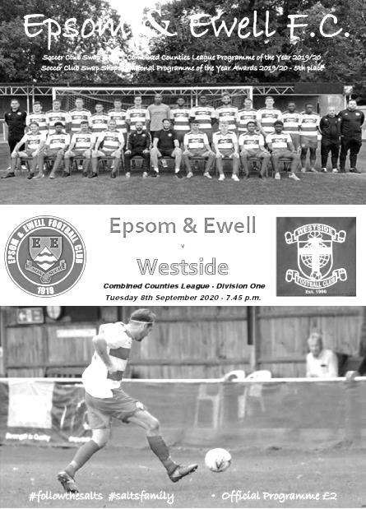
Salts fluff their lines on Grove debut

For the second time in two league matches our team looked quite good in the opening half, only to fall away after the break and concede late goals. However, on this occasion the circumstances were far worse as we conceded three times in the final fifteen minutes of the game and this was despite our visitors going down to ten men after 70 minutes!

Our first outing at Fetcham Grove attracted a healthy crowd of 73, which was our second largest home attendance in the last three seasons, fractionally short of the 78 who watched us defeat Godalming Town in the League in August 2019. The biggest concern now is how many will return after a disappointing performance across the park which didn't see us register a shot that troubled the visiting keeper in the entire 90 minutes.

Credit should also be given to Westside. Clearly high on confidence, having won their opening two competitive fixtures and with an F.A. Cup tie to look forward to this weekend, they chased everything down. We may have held the balance of possession in the first half, but didn't get any space at any time and a number of shots were deflected wide or blocked as a result of a committed defensive display that ultimately kept them in the game and allowed them to have a chance of taking the points at the end.

We made one change to the starting eleven with Bobby Bennett being restored to the line up on the right. This was to replace the absent Tom Penson which also meant we had to play Tariq Straker at left back after his fine display on the wing at AFC Hayes on Saturday. His probing runs would be missed.

There was no real sign of the trouble ahead in the early stages though and Smith's early shot was deflected just wide in the fourth minute with another strike on goal from Rob Hendry a minute later also having the sting taken out of it by a defender's challenge; the ball going through harmlessly to Giordano Zabotti in the Westside goal. In response Westside put a shot wide from a decent position on the quarter hour mark and two minutes later another shot deflected off a team mate and forced Sheikh Ceesay into a low save, although the team mate was in an offside position and the whistle ended the attack.

Zabotti's weak clearance gave Ijah Currie-Wilson a chance on goal, but this too was deflected

wide. After 25 minutes Westside's Alex Lever brought down Smith in full flight and picked up a yellow card and Currie-Wilson was then fouled on the edge of the box but he sent the free kick harmlessly over the bar before John Jupp also picked up a card as Currie-Wilson went down once more, but in a wider position. The free kick was wasted, as like many other deliveries on the night it failed to clear the first man.

Despite this, as the teams went off for half time it still felt as though we would break through in the second period, but as with Saturday's match it didn't happen. Hendry nearly tricked his way through on goal and conjured up a header for himself, but it was straight at Zabotti from a few yards out. We then had a warning as a right wing attack resulted in a dangerous ball across our six yard box where fortunately there was no one there to take advantage. Back at the other end another clearance from Zabotti found Jake Robinson and he set Smith up, although again his shot was blocked away off the impressive Szyrus Shokoya for a corner that came to nothing.

The match took a turn in the 70th minute. Dan Penfold had just been introduced into the action and within a minute he appeared to be caught in the face out on the touchline by a stray arm which belonged to Lever, who then received a second yellow card for his actions. This should have been the moment for us to take control of the match and as we pushed Hendry set up Penfold, but his shot was blocked away. Hendry received a yellow card for a studs up challenge as we continued to press, but it all went pear shaped in the 80th minute as we tried to pass across the back four and Dwayne Agyemang was caught in possession by Tevon Webster who ran through and drilled the ball under Ceesay for the opening goal.

We pushed for an equaliser, but the service all night was poor and from a right wing delivery that was headed clear in the 91st minute Webster broke away and curled the ball around Ceesay for his second. As we entered the ninety-fifth minute Webster tried his luck from 20 yards and the ball flew off Ceesay and into the corner of the net to give him his hat trick.

Westside won this match because they worked harder throughout, particularly when down to ten men. It would have been interesting to know what mileage their players covered, compared to ours. Despite having a very large pitch to work with, we were never given any time and space whatsoever. We have seen over the last couple of seasons that work rate is essential at this level. Westside play nice football and were arguably a bit naive last year when we defeated them twice, but have learned their lesson and look set for a good run this year. We however, have started the season as we did the previous one with two defeats and still appear to have many defensive frailties. Worse still, we currently look light up front and the service to Hendry was very poor from either flank. Further late goals, albeit while we were pushing up to try and level the match, need to be reduced, if not eliminated urgently.

Saturday's upcoming match against Sandhurst Town at Bracknell Town's ground is now an extremely important match for two teams who both finished last season strongly, but are still waiting for their first point of 2020/21.

Epsom & Ewell: Sheikh Ceesay, Gideon Acheampong, Tariq Straker, Tony Martin ©, Lloyd Connelly, Dwayne Agyemang, Bobby Bennett, Jake Robinson, Rob Hendry,
Ijah Currie-Wilson, Taryn Smith

Subs: Jacob Skelly for Currie-Wilson (62), Dan Penfold for Smith (69),
Lekan Orimolusi for Martin (83)

From behind the goal
Sandhurst Town 0-6 Epsom & Ewell
Combined Counties League - Division One - Saturday 12th September 2020

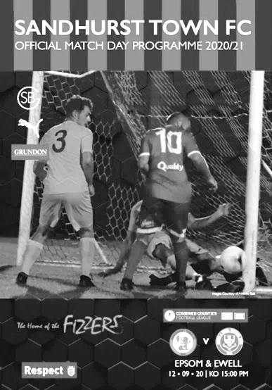
Salts apply "Rule of Six" to the letter

It may not come in for another couple of days, but our boys stuck to the Government advice and made sure that they did not exceed six on Saturday! However, six was plenty to confirm our first victory of the season and it was a comprehensive one over a dispirited Sandhurst team that competed throughout, but struggled against an eleven that was so strong both of our Hall of Fame strikers Rob Hendry and Bobby Bennett were left on the bench.

Playing for the season on the Bracknell Town artificial surface, while Bottom Meadow receives a thorough refurbishment, this was Sandhurst's opening home league match of the season at a venue that Epsom know well, even if we haven't been there since 2004. Since then the venue has been totally rebuilt, although it looked strangely similar in places.

Going into this match after the home defeat by Westside there would have been plenty to address and our Management team brought in a couple of well known local players who made a significant difference. Firstly Charlie Penny who had been at Chipstead, Merstham, Woking, Wealdstone, Welling United, Dulwich Hamlet and Lewes amongst other clubs, brought valuable experience despite only being 25, while Jordan Martin who had also been a former Club Captain at Chipstead, added a bit of steel at the back. There was one further notable change which was the return of Nic Taylor who had returned to the club in pre-season after being with us briefly in 2011/12, although injury had kept him out to this point. One flying save apart, he had a fairly quiet afternoon as we dominated proceedings right from the start.

We took the lead in the third minute. We had nearly scored just before then as Penny's shot across the box was met by Dan Penfold, but his contact went straight at Sonny Wheeler in the Sandhurst goal. However, there was to be no respite and a pinpoint cross from Ijah Currie-Wilson was headed in by Penny. It was a very quick debut goal and our quickest for just over twenty-five years when another blonde striker Stuart Miller made his mark within a minute of coming on in December 1994, although Penny wasn't finished yet and a second goal would follow later.

Taryn Smith was next to strike at goal in the twelfth minute but his shot was deflected wide by a defender and Lloyd Connelly was just over the bar with a header from a Jake Robinson corner. Tony Martin put another header wide at full stretch, but it was apparent that the quality of the deliveries was vastly superior to that against Westside and this was underlined

after 29 minutes when Connelly was first again to a Robinson corner and he headed the ball over the line from close range to double the lead.

We continued to dominate with Penny and Currie-Wilson in particular causing all sorts of trouble and the pair linked up again in the 40th minute when Penny got the final touch after a brilliant run and pass across goal from our left winger. The close control was superb to watch and Currie-Wilson was unfortunate not to claim the goal he deserved after his shot moments later hit team mate Robinson and dribbled towards the keeper when it looked from behind the goal as though it would beat him. Just before the half time whistle Jordan Martin did well to keep a shot down, although he was at the far post and Wheeler was well-positioned to make the save.

With the match as good as over as a contest we could easily have cruised through the second half, but well aware that another couple of goals would put us back into the plus column on the goal difference we kept pushing and extended our lead in the 69th minute. Tony Martin had just seen his header blocked for a corner and from Robinson's delivery Jordan Martin sent a thumping header against the bar from only just inside the penalty area, only to watch brother Tony force the loose ball in from close range.

The final twenty minutes were dominated by substitute Bennett. Despite only coming on after 67 minutes for the tiring Currie-Wilson he scored twice and had a third goal wrongly ruled out for offside. His first, and our fifth goal came in the 75th minute when his run was found by an excellent pass from Jake Robinson and he finished across Wheeler from ten yards. Three minutes later Hendry set up Penfold on the left and our avid filmer Gary Jarman was excellently positioned to show that Bennett was onside when he finished off the low pass. Unfortunately the Assistant on the far side didn't agree! Undeterred, Bennett ran onto another good pass on two more occasions; dragging his shot just beyond the far post in the 85th minute but finishing a more difficult chance under pressure from a defender just two minutes later to complete the scoring on the day.

There was only one concern which came when Robinson was fouled in injury time and his reaction led to a bit of a scuffle involving a number of players. There was no need for our boys to get involved at six-nil up and we need to retain our discipline in these cases, but luckily only Joao Jardim for Sandhurst picked up a card for the original trip and Hendry had a final couple of shots in the final ten minutes, both from wide out, but both on target before the final whistle went and with Epsom winners by six goals to nil.

But how good was this performance? It's no secret that on this form our opponents have a long season ahead of them, and indeed they sacked their Manager within a few hours of this result, so arguably we were just doing the same as previous opponents had. However, we inflicted their heaviest defeat of the season, two goals better than the result obtained by Westside seven days previously, so credit is due for a job well done on the day. Now the trick is to take this result into Tooting on Tuesday and pick up another three points, even though the unbeaten Bec side will provide a tougher challenge.

Epsom & Ewell: Nic Taylor, Gideon Acheampong, Tariq Straker, Tony Martin ©,
Lloyd Connelly, Jordan Martin, Dan Penfold, Jake Robinson, Charlie Penny, Taryn Smith, Ijah Currie-Wilson

Subs: Bobby Bennett for Currie-Wilson (67), Alpha Bah for J.Martin (73),
Rob Hendry for Penny (76)

From behind the goal
Tooting Bec 2-1 Epsom & Ewell
Combined Counties League - Division One - Tuesday 15th September 2020

Déjà vu at Tooting Bec

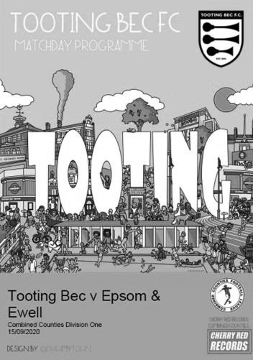
Last November we travelled to Imperial Fields, home of Tooting & Mitcham United and were edged out of a League match by a late winner in a 2-1 defeat. This season the situation was repeated, even right down to our scorer on the night, Jake Robinson. Unlike last season though, where we were quite weak, this match was one we really ought to have taken something from and have only ourselves to blame after once again letting a lead slip.

We started with what appears to be our strongest eleven right now. Ijah Currie-Wilson could consider himself a little unfortunate to start on the bench after a fine performance on Saturday at Sandhurst, but with Rob Hendry and Bobby Bennett back in the starting line up there was a lot of experience for this important match. We also welcomed back Scott Murphy and Conor Young for the first time this season, although both had to be content with a place on the bench.

We worried the home team early on with a free kick which was headed on by Hendry and deceived Kevin Manuel in the Tooting goal but the ball was cleared for a corner that came to nothing. Then it was our hosts turn to attack after a loose header from Gideon Acheampong and a left wing cross which was delivered to an unmarked player at the far post where a powerful low shot was blocked by either Nic Taylor in our goal, or a defender. The game continued to swing from end to end and in the eighth minute Taryn Smith struck a powerful effort at goal where Manuel provided a fine block.

Tooting had another threat on goal in the tenth minute when a twenty-five yard free kick was tipped onto the bar by Taylor and the ball was cleared. It was hard to imagine that this match could finish goalless at this point, yet it continued to remain so. Smith had another effort headed away but only as far as Bennett whose low shot across Manuel was well held. Unfortunately Acheampong's evening would be over in the 33rd minute, having required treatment earlier in the match and Alpha Bah came on and held his own on the right.

As the half concluded we were pushed back a little as the home side forced a few corners. However, we weathered the pressure and went in for the half at 0-0.

We started the second half brightly. In the 48th minute Bennett sent the ball in to Hendry whose clever back flick found Robinson on the edge of the box. He took a good touch to get the ball onto his right foot but then blazed over with the goal at his mercy. Two minutes later Smith robbed a defender on the left and his shot was blocked for a corner. From that delivery Charlie Penny saw his shot blocked on the line with shouts for handball, but we couldn't see anything obvious behind the goal and the game continued.

In the 54th minute we finally broke through. Hendry was fouled about thirty yards out. It was one of those fouls that would never have been awarded twenty years ago as our man ducked down a little and the defender cleared the ball with a slightly high foot, but Robinson's delivery appeared too deep at first and looked like it was going straight to their keeper. However, Manuel was a little

bit off his line and the ball dropped over him into the far corner. For the older readers of this report, you will all remember Ronaldinho's free kick for Brazil that knocked England out of the World Cup in 2002 and this was very similar. Whether our man was actually trying to do this is something only he will know, but we were ahead and after losing a match at AFC Hayes to a deep cross that floated over everyone, we were maybe due a break.

But could we actually hold on to this lead? We had struggled to do exactly that on a number of occasions in pre-season but looked a bit more solid in this match so maybe we would be able to hold on to a lead and squeeze out the points? Regrettably not. In the 61st minute Tooting had a free kick which was headed straight at Taylor and in the 64th minute they were level as we failed to clear a corner and a pinpoint right wing cross was headed in by Tyreke Leslie from close range.

We responded well with Penny latching on to a quick Jordan Martin free kick, but Manuel was equally alert and blocked the shot which then fell to Bennett whose deep cross was headed at goal by Smith, although by this time Manuel had recovered his position to save again. Murphy entered the fray for the final twenty minutes and we threatened again after a Tony Martin delivery had led to a Manuel fumble under pressure from Murphy. The ball dropped to Bennett just ten yards out and his shot was low and powerful enough, but was blocked by a defender on the line.

Moments later Bennett just got to a ball ahead of a defender who brought him down, but the referee didn't even see this as a foul! The game was getting more stretched and there was a crying need for someone of either team to just put a foot on the ball and slow the game down but it didn't happen and just after the hosts had made a double substitution they went ahead. For all our nice football, we still seem to get undone by a long deep ball. On this occasion in the 80th minute Lloyd Connelly was the man tasked with dealing with it, but he was out muscled by Ali Wiltshere who broke through. Taylor made an excellent stop from his shot, but the ball looped up in the air and was nodded in from close range by substitute Jacob Kemp. Was Connelly fouled? Should he have cleared it, or maybe more importantly, why were we left one on one at the back in the first place? Either way, we were behind and this would prove to be terminal.

We tried to recover a point with Connelly almost scoring with a brave header that was well saved before the offside flag was raised and Currie-Wilson almost produced a moment of magic as he beat three players only to see his shot from twenty yards take a slight deflection that sent it inches wide of the top corner. Unfortunately by that time we had been reduced to ten men after Tariq Straker had kicked out unnecessarily at a defender and was sent off, leaving him out for the next three league matches.

Our opening four game sequence in the league always looked difficult with matches against teams that were all in the top ten last season and if someone had offered me a positive goal difference after those four matches I'd probably have taken it! In those four matches we have trailed for a total of just 25 minutes out of 360, yet we have lost three of them. One way or another we need to find a way of pinching these tight matches and we need to do it urgently before the top four clubs open up a gap we are unable to close. Fortunately we now have an F.A. Vase match to concentrate our minds before diving back in for a couple more important league matches at Leatherhead against Cove and Chessington & Hook United respectively.

Epsom & Ewell: Nic Taylor, Gideon Acheampong, Tariq Straker, Tony Martin ©,
Lloyd Connelly, Jordan Martin, Bobby Bennett, Jake Robinson, Rob Hendry,
Charlie Penny, Taryn Smith

Subs: Alpha Bah for Acheampong (34), Scott Murphy for Hendry (74),
Ijah Currie-Wilson for T.Martin (82)

This Day In History – 20th September
Date | Day | Competition |  | Opponents |  | Scorers
20/09/24 | Sat | Surrey Senior League | H | Weybridge | 1-1 | S.Bristow (pen)
20/09/30 | Sat | F.A. Cup  Preliminary Round | H | Tooting Town | 4-1 | G.Mackesy (pen), J.Parr, T.Jones, R.Marlow
20/09/33 | Wed | F.A. Cup Preliminary Round replay | H | Woking | 5-2+ | L.Marlow (4), L.Graves
20/09/47 | Sat | F.A. Cup  Preliminary Round | H | Brookwood Hospital | 4-3 | F.Chitty, W.Webber, N.Harris, A.Davis
20/09/52 | Sat | Amateur Cup Preliminary Round | H | Devas Institute | 3-0 | B.Goddard, D.Ford (pen), S.Scott
20/09/58 | Sat | Corinthian League | H | Leatherhead | 2-6 | T.Higgins, J.Sorensen
20/09/69 | Sat | F.A. Cup 1q | H | Tilbury | 0-1
20/09/75 | Sat | Surrey Senior Cup 1q | H | Banstead Athletic | 0-1
20/09/80 | Sat | Isthmian League 1 | H | Bishop's Stortford | 1-1 | F.Samoth
20/09/83 | Tue | Isthmian League 1 | A | Clapton | 0-0
20/09/86 | Sat | Isthmian League 1 | H | Staines Town | 2-2 | J.Francis, R.Purvis
20/09/94 | Tue | Associate Members Trophy 1 | A | Oxford City | 1-4 | N.Webb
20/09/97 | Sat | Isthmian League 3 | A | Camberley Town | 1-1 | A.Rawlinson
20/09/03 | Sat | Isthmian League 1s | A | Molesey | 0-2
20/09/08 | Sat | F.A. Vase 2q | A | Saltdean United | 1-0 | G.McLaughlin
20/09/14 | Sat | Combined Counties Premier Division | A | Knaphill | 4-1 | S.White (2), T.Smith, D.Marvell
Historical Decades
Date | Day | Competition |  | Opponents |  | Scorers
90 years ago – Epsom Town F.C.
20/09/30 | Sat | F.A. Cup Preliminary Round | H | Tooting Town | 4-1 | G.Mackesy (pen), J.Parr, T.Jones, R.Marlow
70 years ago – Epsom F.C.
23/09/50 | Sat | Amateur Cup Preliminary Round | A | Surbiton Town | 4-2 | S.Faggetter (pen), P.Jordan, B.Musto, o.g.
60 years ago – Epsom & Ewell F.C.
17/09/60 | Sat | Corinthian League | H | Maidenhead United | 2-3 | B.Hawkins, P.Keary
50 years ago – Epsom & Ewell F.C.
19/09/70 | Sat | F.A. Cup 1q | A | Guildford City | 0-5
40 years ago – Epsom & Ewell F.C.
20/09/80 | Sat | Isthmian League 1 | H | Bishop's Stortford | 1-1 | F.Samoth
30 years ago – Epsom & Ewell F.C.
22/09/90 | Sat | Isthmian League 2s | H | Cove | 2-2 | J.Boxall, L.Harding
20 years ago – Epsom & Ewell F.C.
23/09/00 | Sat | F.A. Vase 2q | A | Windsor & Eton | 1-0 | D.Marvell
10 years ago – Epsom & Ewell F.C.
21/09/10 | Tue | Combined Counties League Cup 1 | A | Cove | 2-1 | M.Jarman, T.Cuff

History Corner – 20th September
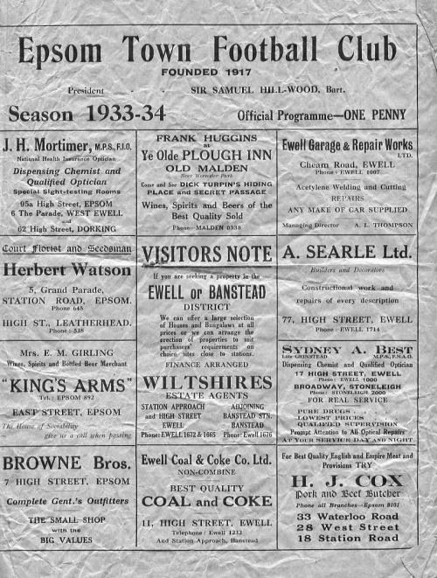
87 years ago today Isthmian League Woking visited us for an F.A. Cup replay, having drawn 1-1 at Kingfield the previous Saturday. We needed a second half equaliser from Tommy Dunne in the first match and in the replay we also trailed at the half and Woking extended that lead early in the second half. They nearly scored a third, but Bob Gates cleared off the line with Jack Forster beaten on the hour mark and we started to fight back from there. The two Leslies, Graves and Marlow both hit the target and we forced extra time where we ran away with it to win 5-2 with Marlow scoring three more goals. (see programme pictured)

Who’d have known at the time that we’d go all the way past Nunhead, Tooting & Mitcham United, Beddington Corner and Leytonstone into the First Round Proper where we were defeated 4-2 by Clapton Orient at their old Lea Bridge Road ground in front of nearly 10,000 spectators!

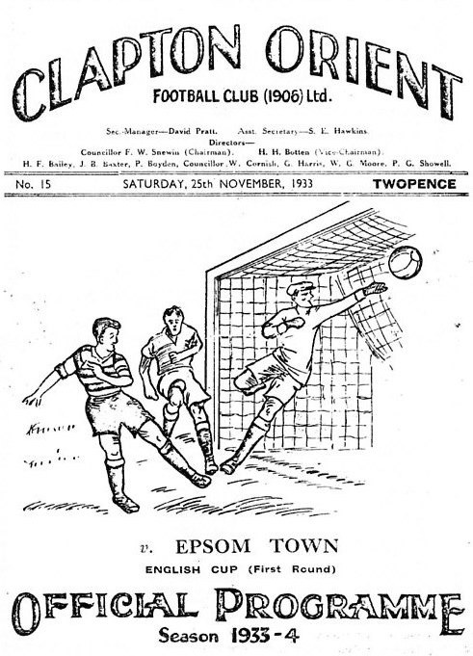

12 years ago today we travelled to Saltdean United for our only previous F.A. Vase match on this date. Saltdean had been as high as Step Five but were at the time a Step Seven side. However, we still made a meal of it and required a Gary McLaughlin goal in the second half to progress to the First Round Proper where we would produce an abject performance at Chichester City.

10 years ago this week goals from Mark Jarman and Tony Cuff enabled us to win 2-1 at Cove in the First Round of the Combined Counties League Cup. This was all the more impressive as a result because Cove were the holders of the cup at the time. We would reach the third round this year before losing 3-1 after extra time at Merstham to Camberley Town.

6 years ago today we visited Knaphill for Glyn Mandeville’s first match as Manager, following the departure of Lyndon Buckwell. We got off to a flying start with an early goal from Sean White and won 4-1 in the end. White got a second goal while Taylor Smith got one and Dale Marvell scored from a considerable distance to claim our fourth goal.

Centre page for results

Centre page for results



CCL Division One Club Directory
AFC HAYES: Telephone: 0208 845 0110 - Colours: Blue and White Stripes/Blue/Blue
Ground: Farm Park, Kingshill Avenue, Hayes, Middx. UB4 8DD

ASH UNITED: Telephone: 01252 344264 - Colours: Green with Red Trim/Green/Green
Ground: Shawfields Stadium, Youngs Drive, Shawfields Road, Ash, Aldershot. GU12 6RE

BAGSHOT: Telephone: 01252 623804 - Colours: Yellow/Black/Black
Ground: Camberley Town FC – Krooner Park, Wilton Road, Camberley. GU15 2QW

BEDFONT & FELTHAM: Telephone: 0208-890 7264 - Colours: Yellow/Blue/Blue
Ground: The Orchard, Hatton Road, Bedfont. TW14 9QT

BRITISH AIRWAYS: Telephone: 0208-890 7264 - Colours: Sky Blue/Navy Blue/Navy Blue
Ground: Bedfont & Feltham FC - The Orchard, Hatton Road, Bedfont. TW14 9QT

CHESSINGTON & HOOK UNITED: Telephone: 01372-602263 Colours: All Blue
Ground: Chalky Lane, Chessington. KT9 2NF

COVE: Telephone: 01252 543615 Colours: Yellow/Black/Black
Ground: Oak Farm, Squirrel Lane, Cove GU14 8PB

DORKING WANDERERS RES Telephone: 01306 400151 - Colours: Red & White Stripes/ Blue/ Red
Ground: New Meadowbank Stadium, Mill Lane, Dorking. RH4 1DX

EPSOM & EWELL Telephone: 01372 360151
Colours: Royal Blue & White Hoops/Royal Blue/Royal Blue
Ground: Leatherhead FC – Fetcham Grove, Leatherhead. KT22 9AS

EVERSLEY & CALIFORNIA Telephone: 0118 973 2400 - Colours: - White & Royal Blue Hoops /Royal Blue/ Royal Blue - Ground: Fox Lane, off Reading Road, Eversley. RG27 0NS

FARNHAM TOWN Telephone: 01252 715305 - Colours: - Claret & Sky Blue /White/ Claret & Blue
Ground: Memorial Ground, Babbs Mead, West Street, Farnham. GU9 7DY

FC DEPORTIVO GALICIA Telephone: 0208 831 9067 - Colours: Royal Blue/Royal Blue/White
Ground: Bedfont Sports FC - Bedfont Sports Club, Hatton Road, Bedfont. TW14 9JR

FLEET SPURS Telephone: 01252 662810 - Colours: Dark Blue with Red Trim/Dark Blue/Dark Blue
Ground: Kennels Lane Farnborough. GU14 0ST

GODALMING TOWN Telephone: 01483 417520 - Colours: Yellow/Green/Yellow
Ground: Wey Court, Meadrow, Godalming. GU7 3JE

JERSEY BULLS Telephone: 01534 449615 - Colours: Red and White
Ground: Springfield Stadium, Janvrin Road, St Helier, Jersey. JE2 4LF

KENSINGTON & EALING BOROUGH Telephone: 0208 998 1701- Colours: All Blue
Ground: Hanwell Town FC – The Powerday Stadium, Perivale Lane (off Argyle Road) W13, Perivale, Greenford UB6 8TL

SANDHURST TOWN Telephone: 01252 878768 - Colours: Blue and Yellow/Blue/Blue
Ground: Bottom Meadow, Sandhurst Memorial Park, Yorktown Road, Sandhurst. GU47 9BJ

TOOTING BEC Telephone: tba - Colours: Black & White Stripes/White/White & Black
Ground: Tooting & Mitcham United FC - Imperial Fields, Bishopsford Road, Morden, Surrey SM4 6BF

WALTON & HERSHAM Telephone: 07969 068731 - Colours: All Red
Ground: Elmbridge Excel Sports Hub, Waterside Drive, Walton-on-Thames. KT12 2JP

WESTSIDE Telephone: 0208 942 8062 - Colours: Yellow/Blue/Blue
Ground: Colliers Wood United FC – Wibbandune Sports Ground, Robin Hood Way, Wimbledon, London SW20 0AA

EL Records Premier Challenge Cup
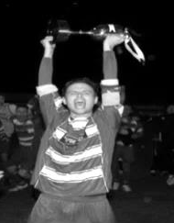
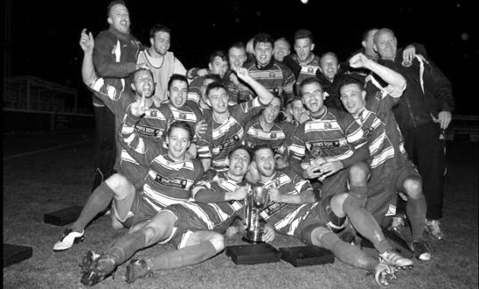
First Round
Redhill | v | Bagshot
Sandhurst Town | v | British Airways
Banstead Athletic | v | Badshot Lea
Godalming Town | v | CB Hounslow United
Tooting Bec | v | Ascot United
Abbey Rangers | v | Cove
Frimley Green | v | Sheerwater
Colliers Wood United | v | Egham Town
Second Round
2 | v | Raynes Park Vale
Westside | v | 1
Ash United | v | Kensington & Ealing Borough
Sutton Common Rovers | v | Spelthorne Sports
Farnham Town | v | 3
Molesey | v | Cobham
Eversley & California | v | Hanworth Villa
Guildford City | v | Bedfont & Feltham
Fleet Spurs | prov | Jersey Bulls
Camberley Town | v | 6
Walton & Hersham | v | Southall
Epsom & Ewell | v | AFC Hayes
4 | v | FC Deportivo Galicia
Knaphill | v | Dorking Wanderers Reserves
8 | v | 7
5 | v | Chessington & Hook United

Esoteric Records Challenge Cup
Different format this year – some under 23 sides invited also
First Round
Walton & Hersham | v | Bagshot
Knaphill U23 | v | Eversley & California
Tooting Bec | v | Farnham Town
Molesey U23 | v | Merstham U23
Bedfont & Feltham | v | AFC Hayes
Ash United | v | Kensington & Ealing Borough
Epsom & Ewell | v | Redhill U23
Fleet Spurs | v | Dorking Wanderers Reserves
Cove | v | Sutton Common Rovers U23
Westside | v | Sandhurst Town
Second Round – not drawn yet

Our Club Statistical History - (incl Tuesday 15th September):
For the purposes of these records, all matches that resulted in penalty shoot outs are recorded as draws, regardless of whether they were won or lost.

All League: Played: 2,987, Won: 1,223, Drawn: 568, Lost: 1,196
For: 5,499, Against: 5,317, GD: + 182 - Win Ratio 40.94%

CCL Only: Played: 566, Won: 249, Drawn: 110, Lost: 207
For: 1,033, Against: 931, GD: + 102 - Win Ratio 43.99%

Cup and Other: Played: 1,136, Won: 538, Drawn: 131, Lost: 459
For: 2,469, Against: 2,126, GD: + 343 - Win Ratio 47.36%

Abandoned Matches: Played: 8: For: 14, Against: 16

Under Sam Morgan: Played 13, Won: 7, Drawn: 3, Lost: 3
For: 28, Against: 13, GD: + 15 - Win Ratio 53.85%

Overall: Played 4,123, Won: 1,761, Drawn: 699, Lost: 1,655, Abandoned: 8
For: 7,968, Against: 7,443, GD: + 525 - Win Ratio 42.71%

Record Win:
12/10/1935 - 13-1 v Reigate Priory (H) - Amateur Cup

Record Defeat:
14/02/1948 - 0-14 v Chelmsford City Reserves (A) - London League

Bridon Ropes F.C. – History

Bridon Ropes F.C. began life as a factory team back in 1935. It was founded by workers at the British Ropes Works in Charlton, London, and unsurprisingly became known as British Ropes F.C.

In the early days we played in various local leagues with home matches being played at our home ground within the factory grounds until eventually joining the South London Amateur League.

Several years later we found ourselves playing in the Greater London League which they left in1975 to join the London Spartan League still under the name of British Ropes but in 1990 the Factory changed its name to Bridon Ropes and the football club changed its name to Bridon Sports. They then won Division Two of the Spartan League in 1991–92 and the London Junior Cup. In 1992 the club changed its name to the current Bridon Ropes FC.

In 1997 we became founder members of the Spartan South Midlands Football League Division One South. However we left the league the following season to become founder members of the London Intermediate League.

Bridon Ropes later joined the Kent County League Division One and became Champions in the 2009 season, achieving promotion to the Premier Division.

In 2011 we became founder members of the Kent Invicta Football League. This League was eventually amalgamated with the Kent League which changed its name to the Southern Counties East Football League, which now has two divisions. The Kent Invicta League teams formed the new Division One of this League.

Since then, our League finishes have been:

2011/12 - 4th / 16
2012/13 - 7th / 16
2013/14 - 8th / 15
2014/15 - 10th / 16

2015/16 - 5th / 20
2016/17 - 7th / 19
2017/18 - 5th / 19
2018/19 - 4th / 18
2019/20 - 13th / 17 (season curtailed)

League Honours

London Spartan League 2 Winners 1992-1993
Kent County League Division 2 Runners Up 2005-2006
Kent County League Division 1 Winners 2009-2010

Cup Honours

Kent Junior Cup Winners 1992-1993
London Intermediate League Cup Winners 1999-2000
London Intermediate League Cup Winners 2000-2001
London Senior Trophy Winners 2013-2014

Southern Counties East League Division One Table
Incl Tuesday 15th September | P | W | D | L | F | A | Pts | GD
Kennington | 2 | 2 | 0 | 0 | 10 | 2 | 6 | +8
Rochester United | 2 | 2 | 0 | 0 | 7 | 2 | 6 | +5
Greenways | 2 | 2 | 0 | 0 | 6 | 1 | 6 | +5
FC Elmstead | 2 | 1 | 1 | 0 | 5 | 3 | 4 | +2
Croydon | 2 | 1 | 1 | 0 | 5 | 4 | 4 | +1
Snodland Town | 2 | 1 | 1 | 0 | 3 | 2 | 4 | +1
Rusthall | 2 | 1 | 0 | 1 | 7 | 4 | 3 | +3
Holmesdale | 2 | 1 | 0 | 1 | 7 | 6 | 3 | +1
Lydd Town | 2 | 1 | 0 | 1 | 8 | 8 | 3 | 0
Sutton Athletic | 2 | 1 | 0 | 1 | 2 | 6 | 3 | -4
Lewisham Borough | 2 | 0 | 2 | 0 | 2 | 2 | 2 | 0
Meridian VP | 2 | 0 | 1 | 1 | 1 | 3 | 1 | -2
Sporting Club Thamesmead | 1 | 0 | 0 | 1 | 2 | 4 | 0 | -2
Stansfeld | 1 | 0 | 0 | 1 | 3 | 6 | 0 | -3
Forest Hill Park | 2 | 0 | 0 | 2 | 1 | 5 | 0 | -4
Kent Football United | 2 | 0 | 0 | 2 | 2 | 7 | 0 | -5
Bridon Ropes | 2 | 0 | 0 | 2 | 1 | 7 | 0 | -6



Above and Below
Combined Counties League - Premier Division Table
inc Tuesday 15th September | P | W | D | L | F | A | Pts | GD
Knaphill | 4 | 3 | 1 | 0 | 11 | 4 | 10 | +7
Ascot United | 4 | 3 | 0 | 1 | 18 | 4 | 9 | +14
Hanworth Villa | 3 | 2 | 1 | 0 | 9 | 4 | 7 | +5
Abbey Rangers | 3 | 2 | 1 | 0 | 7 | 2 | 7 | +5
Sutton Common Rovers | 3 | 2 | 1 | 0 | 6 | 2 | 7 | +4
Southall | 3 | 2 | 0 | 1 | 8 | 4 | 6 | +4
Raynes Park Vale | 3 | 2 | 0 | 1 | 5 | 4 | 6 | +1
Badshot Lea | 3 | 2 | 0 | 1 | 5 | 5 | 6 | 0
Banstead Athletic | 4 | 1 | 2 | 1 | 4 | 3 | 5 | +1
Sheerwater | 3 | 1 | 1 | 1 | 3 | 3 | 4 | 0
Guildford City | 3 | 1 | 1 | 1 | 3 | 4 | 4 | -1
Cobham | 3 | 1 | 1 | 1 | 6 | 8 | 4 | -2
Spelthorne Sports | 3 | 1 | 0 | 2 | 3 | 3 | 3 | 0
Egham Town | 3 | 1 | 0 | 2 | 5 | 6 | 3 | -1
Camberley Town | 3 | 1 | 0 | 2 | 2 | 3 | 3 | -1
Colliers Wood United | 4 | 0 | 2 | 2 | 6 | 11 | 2 | -5
CB Hounslow United | 2 | 0 | 1 | 1 | 1 | 4 | 1 | -3
Redhill | 2 | 0 | 0 | 2 | 1 | 6 | 0 | -5
Frimley Green | 3 | 0 | 0 | 3 | 3 | 13 | 0 | -10
Molesey | 3 | 0 | 0 | 3 | 2 | 15 | 0 | -13
Following last year’s null and void ending, the proposed F.A. reorganisation was delayed by one year. As a result, this season two clubs will go up for the first time since 2013 and indeed it is possible that a third could go too. At the other end, only one can be relegated, and even then it may not happen, so Molesey, already looking very precarious after a horror start which saw them lose many players on the eve of the season, have plenty of time to save themselves, although any reprieves will be on a points per game basis, so they need to get some points on the board.

Early leaders are Knaphill and Ascot United. Ascot transferred over from the Hellenic League during the summer of 2019. They are another club that, like us, are often overshadowed by the horse racing in their town. Maybe we should meet for a friendly next year!

Hanworth Villa, Abbey Rangers and Sutton Common Rovers all remain unbeaten at this very early stage and I also feel that Southall and Badshot Lea will be there or thereabouts. Last season threatened to be one of the most exciting finishes in history as there were a number of teams in with a chance of the title when the season was curtailed. Hopefully this season we will at least see a natural end to proceedings, fingers crossed!

Regrettably there is no “below” section yet as they only started their matches yesterday!

Combined Counties League Division One
Opponents All-time Records
incl Tues 15th September | P | W | D | L | F | A | PPG | GD | Best  Win | Worst  Loss
Godalming Town | 8 | 7 | 0 | 1 | 22 | 11 | 2.63 | +11 | 5-1 | 0-3
FC Deportivo Galicia | 5 | 4 | 0 | 1 | 13 | 5 | 2.40 | +8 | 3-0 | 0-2
Bagshot | 4 | 3 | 0 | 1 | 12 | 3 | 2.25 | +9 | 7-1 | 1-2
British Airways | 3 | 2 | 0 | 1 | 8 | 5 | 2.00 | +3 | 3-0 | 2-3
Westside | 3 | 2 | 0 | 1 | 6 | 6 | 2.00 | 0 | 3-1 | 0-3
Ash United | 23 | 13 | 4 | 6 | 54 | 34 | 1.87 | +20 | 6-0 | 0-3
Bedfont & Feltham | 7 | 4 | 1 | 2 | 26 | 20 | 1.85 | +6 | 9-2 | 0-5
Cove | 38 | 18 | 10 | 10 | 86 | 60 | 1.68 | +26 | 7-0 | 1-6
Chessington & Hook | 30 | 13 | 9 | 8 | 63 | 45 | 1.60 | +18 | 6-0 | 1-3
Walton & Hersham | 55 | 25 | 11 | 19 | 108 | 111 | 1.56 | -3 | 8-0 | 0-8
Farnham Town | 20 | 9 | 4 | 7 | 32 | 33 | 1.55 | -1 | 3-0 | 1-4
Eversley & California | 2 | 1 | 0 | 1 | 2 | 2 | 1.50 | 0 | 1-0 | 1-2
Sandhurst Town | 19 | 8 | 1 | 10 | 36 | 32 | 1.32 | +4 | 6-0 | 1-3
Dorking Wanderers Res | 5 | 1 | 3 | 1 | 10 | 9 | 1.00 | +1 | 3-0 | 3-5
Fleet Spurs | 4 | 1 | 1 | 2 | 8 | 10 | 1.00 | -2 | 3-2 | 3-5
Kensington & Ealing Borough | 4 | 1 | 1 | 2 | 5 | 9 | 1.00 | -4 | 2-0 | 1-5
Tooting Bec | 5 | 1 | 1 | 3 | 8 | 11 | 0.80 | -3 | 3-1 | 1-4
AFC Hayes  (inc Brook House) | 14 | 2 | 4 | 8 | 20 | 26 | 0.71 | -6 | 7-0 | 1-4
Jersey Bulls | 1 | 0 | 0 | 1 | 0 | 2 | 0.00 | -2 | - | 0-2
Match and Ball Sponsorships – 2020/21
Opponent | Date | Match Sponsor
Westside | 08/09/20 | Club President – Stella Lamont
Bridon Ropes (FA Vase) | 20/09/20 | Paul Merritt
Cove | 26/09/20
Chessington & Hook United | 29/09/20
Match sponsorship costs just £60.00!

Sponsorship includes:

Admission, programmes and hospitality for three people.

A full page advert in the programme and mascot for the day (if required).

Also, you get to choose the player of the match, who will receive a prize

If you are interested, just speak to a Committee Member,
or drop me an email at: richard.c.lambert@gmail.com

You Could Advertise Here!


Just ask a Committee Member for details! Reasonable Prices!
Be a part of our award winning programme!

Welcoming Kall Kwik!
We welcome Kall Kwik Designers & Printers to the Salts family!

They are based in Leatherhead and have taken on the task of producing our Match Day Programme. You can also see from their list below that they can do quite a lot of things. Why not drop them a line, and remember to tell them where you saw the advert!


Season Tickets now available!
Season tickets are available for the season, which cover all remaining League and League Cup ties. We are at home in both cups, so that is an extra two matches FREE!

Adult Season Ticket (over 16) - £100
Concessions (OAPs and Students) - £50
Children aged between 7-16 - £20
Children under 7 – FREE

In addition we are also allowing FREE entry to all Her Majesties Armed Services and Emergency Personnel (proof required)

We also allow all Epsom & Ewell Colts players in FREE
if accompanied by a paying adult.

Reduced prices are available for Leatherhead F.C. season ticket holders – just ask a Committee Member for details and follow the Salts!!

Buildbase F.A. Vase – First Qualifying Round
Sunday, 20th September 2020

Kick-off 3.00 p.m.
Epsom and Ewell  (Royal Blue & White/Blue/Blue) | V |  | Bridon Ropes  (All Burgundy)
Squad | NUMBERS |  | Squad
Nic Taylor |  |  | Daniel Moore
Ben Ashton |  |  | Jonathan Boateng
Gideon Acheampong |  |  | Taylor Bowley
Reisse Griffin |  |  | Joe Brown
Joe Bonass-Ward |  |  | Finlay Chambers
Dwayne Agyemang |  |  | Matt Cunnington
Lloyd Connelly |  |  | Matt Dennis
Alpha Bah |  |  | Bradley Hoffman
Jordan Martin |  |  | Danny Jackson
© Scott Murphy |  |  | Alex Jones
Jacob Skelly |  |  | Gyan kc
Jake Robinson |  |  | Jack Kensington
Tony Martin |  |  | Jack Kirby
Tariq Straker |  |  | Qendrim Murselaj
Bobby Bennett |  |  | James Naylor
Rob Hendry |  |  | Emmanuel Olayinka
Taryn Smith |  |  | Jamie Thuillier
Ijah Currie-Wilson |  |  | Jack Wilson
Dan Penfold |  |  | Janiah Boyd
Jacob Sewell |  |  | Juliano Marku
Charlie Penny |  |  | Marcia Da Costa
Sam Morgan | MANAGER |  | Junior Montgomery
Tim Moffatt | ASSISTANT |  | Peter Chalklin
Tim Moffatt / Ben Ashton /  Kevin Adnett / Colin Harvey | COACHES / PHYSIOS |  | Andy Ferguson /  Michael Parper
REFEREE: D.Sotomirin
ASSISTANTS: R.Alderton, S.Hart
Today’s match is sponsored by
long-serving supporter Paul Merritt

OUR NEXT VISITORS TO FETCHAM GROVE
Cove
Combined Counties League – Division One
Saturday, 26th September 2020 – Kick-off – 3.00 p.m.

